**Government Polytechnic Jalgaon**



Capstone Project -Planning (22058)

Project Proposal

EJ5I

Academic Year 2020-21

**MAHARASHTRA STATE BOARD OF TECHNICAL**

**EDUCATION**

GOVERNMENT POLYTECHNIC, JALGAON

**(0018)**

**Program Name : ELECTRONICS &TELICOMMUNICATION**

**Course Name And Code : Capstone Project -Planning (22058)**

**Academic Year : (2020-21)**

**Semester : Fifth.**

**A CAPSTONE PROJECT**

On

Electrolyte bath parameters monitoring system

|  |  |  |  |  |
| --- | --- | --- | --- | --- |
| **Sr.**  **No.** | **Roll**  **No.** | **Name of student** | **Enrollment**  **No.** | **Seat no.** |
| **1** | **11** | **Prathamesh Saraf** | **1800180265** |  |
| **2** | **23** | **Mohit Bhangale** | **1800180288** |  |
| **3** | **24** | **Mandar Patil** | **1800180290** |  |
| **4** | **25** | **Mohish Khadse** | **1800180291** |  |

**Project Registration**

**Project Title -: Electrolyte Bath Parameters Monitoring System**

|  |  |  |  |
| --- | --- | --- | --- |
| **Sr.**  **No.** | **Roll**  **No.** | **Name of student** | **Enrollment**  **No.** |
| **1** | **11** | **Prathamesh Saraf** | **1800180265** |
| **2** | **23** | **Mohit Bhangale** | **1800180288** |
| **3** | **24** | **Mandar Patil** | **1800180290** |
| **4** | **25** | **Mohish Khadse** | **1800180291** |

**Industry Sponsored Project**

**Industry Name -: Spectrum Electrical Industry Ltd. Jalgaon**

**V -195 , Ajanta road MIDC Jalgaon**

**Industry Mentor : Shri Rade S. D.**

**Mr. K.P. akole**

Mentor & Head of Department

**Rational**

**Process** like deposition, doping, electroplating creates the toxic gases in the processing plant. This gases are used as a catalyst in the process. This gases sre surely enabler in the processing but are highly toxic and can cause concussion when inhaled. Additional acids like HCL are also used in these companies for similar purpose fumes can cause irritation & affect the respiration of the inhaler Whether these gases are used for manufacturing or byproducts of any process in a facility it becomes very important to monitor and control them.

Therefore gas detection system can be easily integrated into existing system & equipment of a company, allowing easy detection of gas leakages that can result in several catastrophe. Quick action can hence be taken to prevent the spread of gas over a wide region. These systems are an essential commodities in such industries. Since the allow them to detect the leakage of noxious and explosive gases maintain proper oxygen level for workers and company with emission regulation norms.

**Introduction**

The project which we are going to make covers two major criteria

1. It is based on the actual industrial problem which is given by company itself (Spectrum Electrical Ltd)
2. And company itself is ready to give the technical sponsorship required for the project

The problem given by the industry is that in the electroplating plant of the industry there is a need of a system which require to monitor a parameters such as liquid PH value,Methane and carbon monoxide gases content of electroplating bath container not only monitoring but the want the data to be fetched in their plant office wirelessly

So the solution for these problem can be to construct the system which will measure such parameters from bath and transmit into the office. These parameters which are water, PH level, Carbon Monoxide gas, methane gas temperature of electrolyte solution can be sensed by the sensors. Sensors output will be feed to the controller where the sensed parameter will be converted in the real time readable format and further send to the office through the transmitter module. At the reception section of the system this data will be displayed on the lcd screen and system such as, if the measured parameter value rises above the required level a small alarm will activate which will inform that parameters of bath had exceeds its tolerating value

**Project Management Cycle**

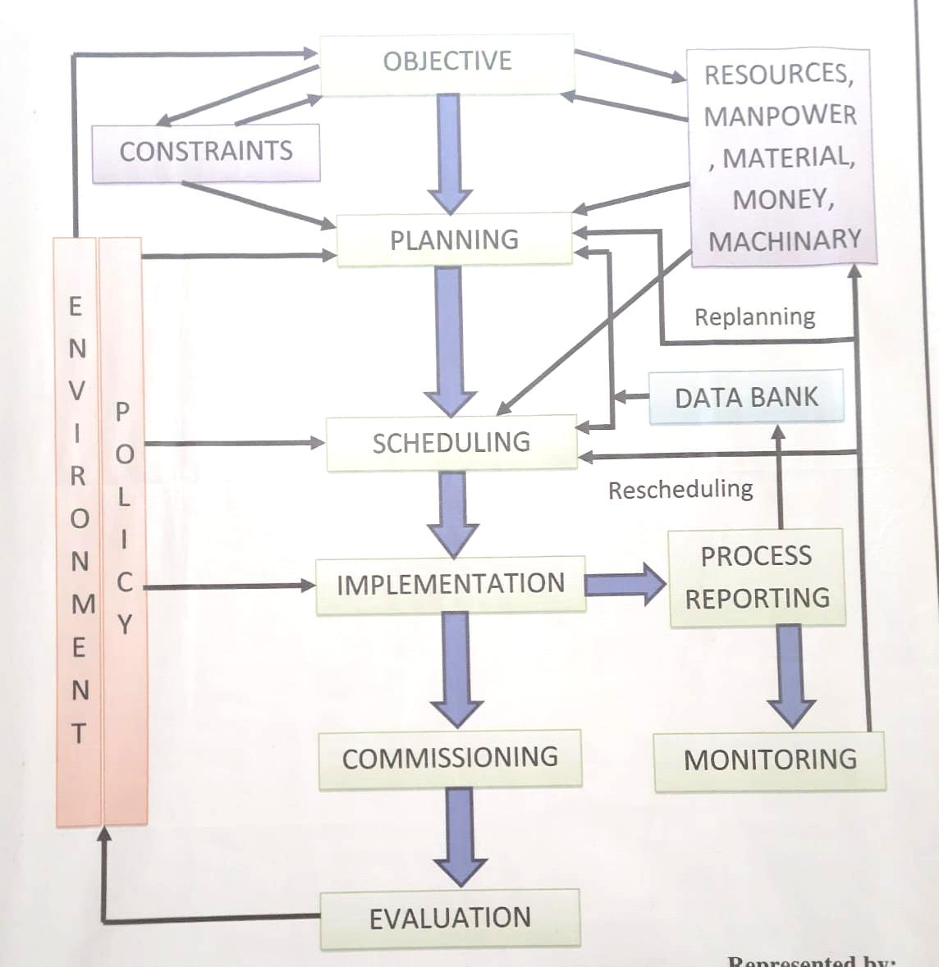

**Block diagram of the system**

RF Transmitter

Controller (Arduino)

Sensors

Alarms

LCD display

Controller (Arduino)

RF Receiver

**Literature survey**

Gas sensors (also known as gas detectors) are **electronic** devices that detect and identify different types of gasses. They are commonly used to detect toxic or explosive gasses and measure gas concentration. Gas sensors are employed in factories and manufacturing facilities to identify gas leaks, and to detect smoke and carbon monoxide in homes.

Gas sensors vary widely in size (portable and fixed), range, and sensing ability. They are often part of a larger [embedded system](https://www.fierceelectronics.com/embedded/what-embedded-computer), such as security systems, and they are normally connected to an audible alarm or interface. Because gas sensors are constantly interacting with air and other gasses, they have to be calibrated more often than many other types of sensors.

MQ2 is one of the commonly used gas sensors in MQ sensor series. It is a Metal Oxide Semiconductor (MOS) type Gas Sensor also known as **Chemiresistors** as the detection is based upon change of resistance of the sensing material when the Gas comes in contact with the material. Using a simple voltage divider network, concentrations of gas can be detected.

An **RF module** (short for **radio-frequency module**) is a (usually) small electronic device used to transmit and/or receive radio signals between two devices. In an [embedded system](https://en.wikipedia.org/wiki/Embedded_system) it is often desirable to communicate with another device [wirelessly](https://en.wikipedia.org/wiki/Wireless). This wireless communication may be accomplished through [optical communication](https://en.wikipedia.org/wiki/Free-space_optical_communication) or through [radio-frequency](https://en.wikipedia.org/wiki/Radio-frequency) (RF) communication. For many applications, the medium of choice is RF since it does not require line of sight. RF communications incorporate a [transmitter](https://en.wikipedia.org/wiki/Transmitter) and a [receiver](https://en.wikipedia.org/wiki/Receiver_(radio)). They are of various types and ranges. Some can transmit up to 500 feet. RF modules are typically [fabricated](https://en.wikipedia.org/wiki/Semiconductor_device_fabrication) using [RF CMOS](https://en.wikipedia.org/wiki/RF_CMOS) technology.

RF modules are widely used in electronic design owing to the difficulty of designing radio circuitry. Good electronic radio design is notoriously complex because of the sensitivity of radio circuits and the accuracy of components and layouts required to achieve operation on a specific frequency. In addition, reliable RF communication circuit requires careful monitoring of the manufacturing process to ensure that the RF performance is not adversely affected. Finally, radio circuits are usually subject to limits on radiated emissions, and require [Conformance testing](https://en.wikipedia.org/wiki/Conformance_testing) and certification by a [standardization](https://en.wikipedia.org/wiki/Standardization) organization such as [ETSI](https://en.wikipedia.org/wiki/ETSI) or the U.S. [Federal Communications Commission](https://en.wikipedia.org/wiki/Federal_Communications_Commission) (FCC). For these reasons, design engineers will often design a circuit for an application which requires radio communication and then "drop in" a pre-made radio module rather than attempt a [discrete](https://en.wikipedia.org/wiki/Discrete_device) design, saving time and money on development.

Several carrier frequencies are commonly used in commercially available RF modules, including those in the [industrial, scientific and medical (ISM) radio bands](https://en.wikipedia.org/wiki/ISM_band) such as 433.92 MHz, 915 MHz, and 2400 MHz. These frequencies are used because of national and international regulations governing the used of radio for communication. [Short Range Devices](https://en.wikipedia.org/wiki/Short_Range_Devices) may also use frequencies available for unlicensed such as 315 MHz and 868 MHz.

RF modules may comply with a defined protocol for RF communications such as [Zigbee](https://en.wikipedia.org/wiki/Zigbee), [Bluetooth Low Energy](https://en.wikipedia.org/wiki/Bluetooth_Low_Energy), or [Wi-Fi](https://en.wikipedia.org/wiki/Wi-Fi), or they may implement a [proprietary protocol](https://en.wikipedia.org/wiki/Proprietary_protocol).

**Problem definition**

The problem given by the industry is that in the electroplating plant of the industry there is a need of a system which require to monitor a parameters such as liquid PH value,Methane and carbon monoxide gases content of electroplating bath container not only monitoring but the want the data to be fetched in their plant office wirelessly

**Proposed Methodology of solving Identified problem**

Methods for solution the identified problem can be as follows

**Flexible system** -: System shiuld be so flexible which will easily adapt the electroplating plant environment.and can be easily transferred to another container. Also if require it can be modified as per further requirement(which includes switching action of the inlet and outlet valve of the electroplating bath,diluting the electrolyte solution etc )

**Wireless system**-: This monitoring system should be wireless because at the actual project implementing site there is no such place to carriy the wires towards office

**Alarm provision** -: System should have the alarm provision which will inform that bath parameters has cross the threshold value.

**Compact Size** -: System should be compact so it can be attached at at the site

**Resources and consumable required**

|  |  |  |
| --- | --- | --- |
| **Sr No** | **Resources Required** | **Specification** |
| 1 | Arduino uno | [Microcontroller](https://en.wikipedia.org/wiki/Microcontroller): [Microchip](https://en.wikipedia.org/wiki/Microchip_Technology) [ATmega328P](https://en.wikipedia.org/wiki/ATmega328P) [[7]](https://en.wikipedia.org/wiki/Arduino_Uno#cite_note-website-7)Operating Voltage: 5 VoltsInput Voltage: 7 to 20 Volts |
| 2 | RF Module | * Wireless (**RF**) Simplex **Transmitter** and Receiver. * Receiver Operating Voltage: 3V to 12V. * Receiver Operating current: 5.5mA |
| 3 | LCD | * Operating Voltage is 4.7V to 5.3V. * Current consumption is 1mA without backlight. |
| 4 | Sensors | |  |  | | --- | --- | | Range | 0°...100°C | | Accuracy | < 0,1°C + NTC-spread over 0°...70°C | | Resolution | 2 m°C@30°C and 25 m°C@100°C | |
| 5 | SMPS | The S.M.P.S operated at input regular voltage AC 100V – 240V. The S.M.P.S should be capable of a total continuous DC power output of 40 Watts. The S.M.P.S should be capable of a total peak 50 Watts. |
| 6 | Arylic Cabinat |  |
| 7 | Connecting Wires | Connecting wires provide a medium to an electrical current so that they can travel from one point on a circuit to another |

**Action Plan**

|  |  |  |  |
| --- | --- | --- | --- |
| **Sr No** | **Detail Activity** | **Planned**  **Start date** | **Planned**  **End Date** |
| **1** | Selecting capstone project | **24/08/2020** | **21/09/2020** |
| **2** | Discussion of project with mentor | **22/09/2020** | **12/10/2020** |
| **3** | Finalization of topic from mentor | **13/10/2020** | **30/10/2020** |
| **When we discuss about our capstone project with industry then industry has given own problem statement then we cancel our topic and start work with industry problem** | | | |
| 1 | Seeking for industry to get technical guidance and problem statement | **27/12/2020** | **27/12/2020** |
| 2 | Selecting topic for project | **27/12/2020** | **01/01/2021** |
| 3 | Discussion of project with mentor | **01/01/2021** | **04/01/2021** |
| 4 | Submitting the proposal of the project | **06/01/2021** | **06/01/2021** |
| 5 | Purchasing the components |  |  |
| 6 | Simulation of the project |  |  |
| 7 | Discuss about programming with industry guide |  |  |
| 8 | Checking of simulation project under industry guide |  |  |
| 9 | Actual implementing the project |  |  |
| 10 | Final submission of the project |  |  |